GlobalSight Setup Guide

1. Getting source code
At the beginning, you need to get the all source code of GlobalSight system which can be found from GlobalSight web page www.globalsight.com.
Unzip or unpackage the codes into a new directory, such as “GlobalSight7.1”. The following paths are default to under this root directory, such as “main6/envoy” means “GlobalSight7.1/main6/envoy”.
If you have download the source code successful, the package structure should be the following:
GlobalSight7.1 ---- HOME
| ---- main6
| ---- diplomat
| ---- envoy
| ---- ling
| ---- noonetime
| ---- softline
| ---- tools

2. System requirement
Before programming, please make sure the dependent softwares has been installed successfully.
Name | Note | Useful Link
JDK | Version 1.5 or later | www.sun.com
Ant | Version 1.7.0 or later | http://ant.apache.org/

3. Build
Because there are some special source codes need be generated by “javacc” command, so we need to build project once before setting up a project or development.
Open a command window, and forward to the folder of “HOME/main6/tools/build/”. Execute the following ant script:
ant dist
The “dist” target will compile whole project and deploy it as zip file into the sub folder “dist” of “build” folder. About more build details, please refer to deploy guide document.

4. Setting up a project
Summarily, setup a project by the GlobalSight system you should know:
- Source folders:
  - main6/diplomat/dev/src/java/*
  - main6/envoy/src/java/*
  - main6/ling/ (only sub folder “com/*” is needed )
- Source code encoding is ISO-8859-1. This is necessary when compiling codes.
- Library files. Most of the library files are in directory “main6/tools/lib/”, and each source folder will have its own library folder. The container library of JBoss is in “main6/tools/j2eeVendor/jboss”. Please make sure all the necessary library files has been added into the class path before development.
Take Eclipse as example, the following shows how to setup a project into it.
Please download an Eclipse from Eclipse web page www.eclipse.org. Version 3.2.x or later is required.

New project
Open Eclipse environment, select “File -> New -> Java Project”.

Import souce code
Input a project name, such as “GlobalSight”.
Select “Create project from existing source” in “Contents” frame under the project name. Click the “Browse” button and forward to the root folder of source code -- “HOME”. See the screen shot 1 for details.
Click the “Next” button to import source codes into Eclipse.
Note: Don't click “Finish” button now. Some default settings need to be modified later.
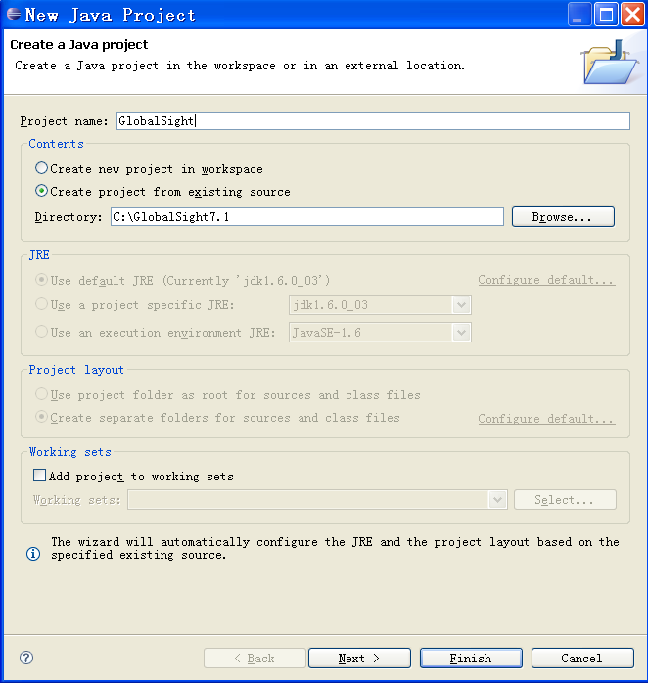Illustration 1: New Java project

Remove all default source folders
After a few seconds or minutes, Eclipse will show the following screen which contains the default settings of GlobalSight project.
Select all the default source folders (actually, all the list folders except the last folder “main6” are default source folders), and then click the link “Remove from Java build path” to remove them from source folder list.
If you have removed them all successfully, there will be only one folder named “main6” left as screen shot 3.
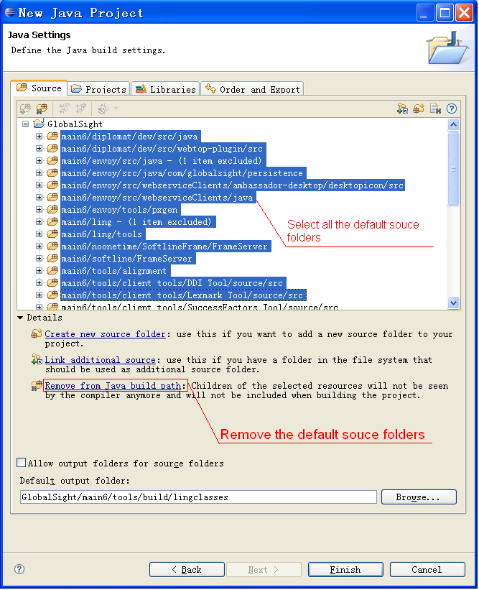Illustration 2: Remove all default source folder
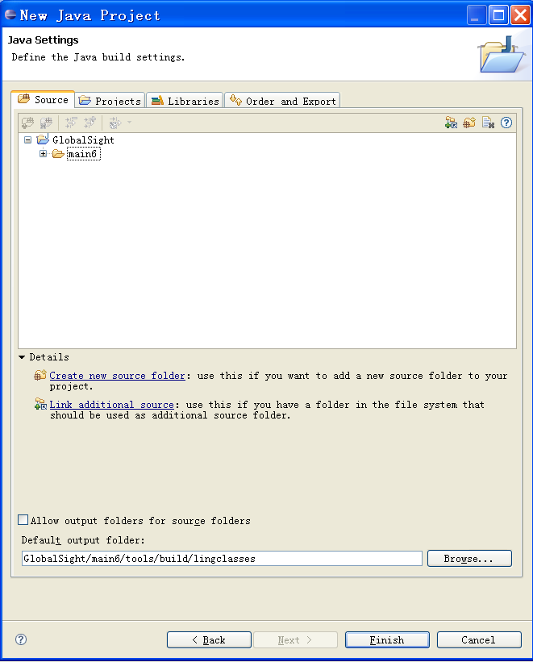Illustration 3: All default source folders have been removed

Add real source folders
Now add the real source folders. There are three necessary source folders in GlobalSight system, including “main6/diplomat/dev/src/java”, “main6/envoy/src/java” and “main6/ling”.
Take the first folder as example, select folder “main6/diplomat/dev/src/java”, and then click the link “Add folder 'java' to build path” to add it as source folder. See screen shot 4 for details.
If you have add all the source folders successfully, you will see the screen shot 5 as following:
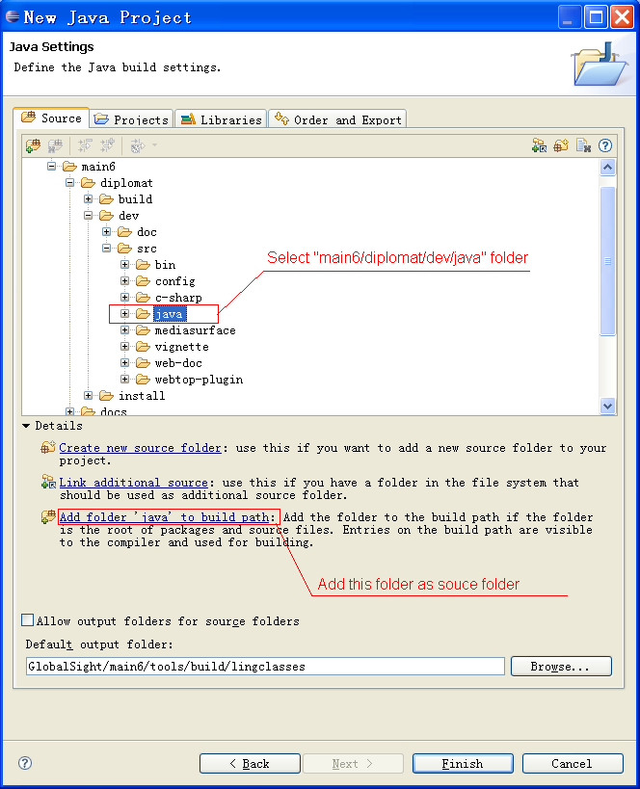Illustration 4: Add source folder
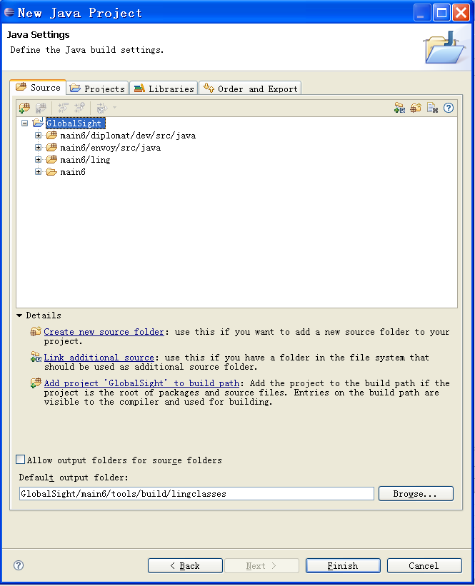Illustration 5: Add all source folders

Filters and output folder
Now you have almost built a new project from GlobalSight system source codes. But here are some other detail setting for improving the project environment.
a. Filter files from source folder
Filter unnecessary files from source folder can reduce the cost of system memory and speed up Eclipse environment.
Take “main6/ling” folder as example, select the source folder and click the link “Configure inclusion and exclusion filters”. See screen shot 6.
The configuration window for inclusion and exclusion will be shown. Click button “Add Multiple ...” in “Exclusion pattern” frame. And then select the sub folders and files except “com” folder, click button “OK” in selection window and then “Finish” button in “Inclusion and Exclusion Patterns” window.
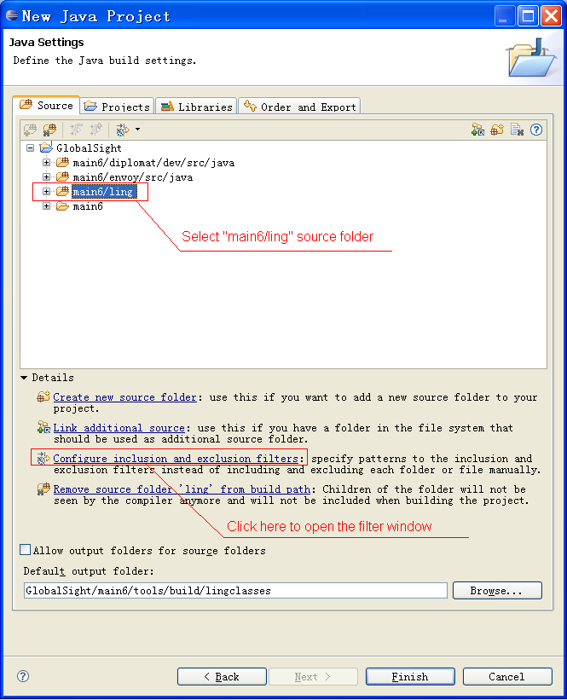Illustration 6: Configure source folder
See screen shot 7 for details.
After this, you can see there are more description sentence after source folder “main6/ling”, such as “6 items excluded”.
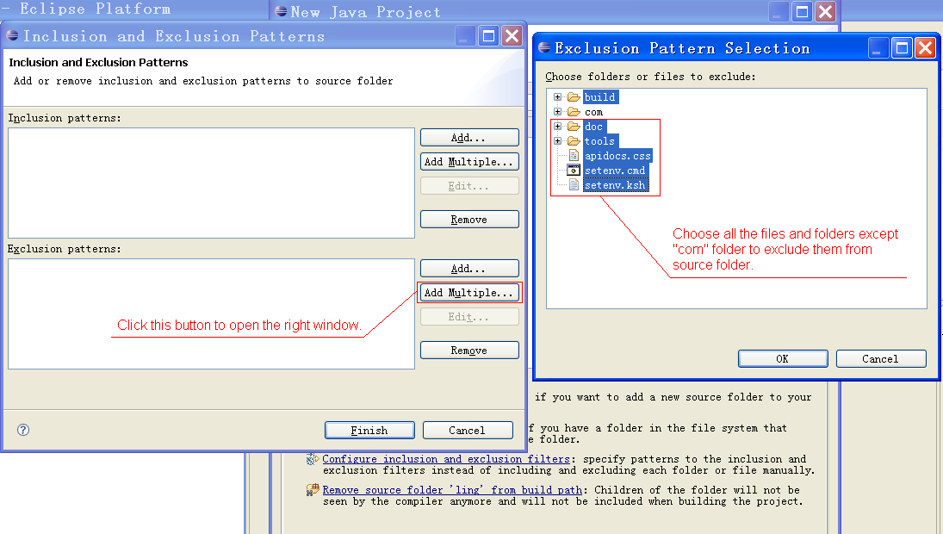Illustration 7: Add filters for ling folder
Here are other files you can exclude from source folder:
“main6/envoy/src/java/com/globalsight/resources/**”,
“main6/ling/com/globalsight/resources/”

b. Modify default output folder
The default output folder of the new GlobalSight project may be strange, such as “GlobalSight/main6/tools/build/cxeclasses” or other ( See the bottom of the project window). If you want to make it as a familiar Eclipse project, you can modify the output folder direction to “GlobalSight/main6/bin” or wherever you want. Using a familiar path will be helpful when you want to find or use the classes files.

Encoding
After all the steps before, now click the “Finish” button to finish the creation process. If you have modified the output folder directory, there may be a pop-up window will ask you to copy files from original directory to new directory. Click “Yes” and then a new project will be created successfully.
Well, Eclipse needs to do some tasks after creation. After that, whatever you have seen some error when compiling or not, please do to modify the file encoding of GlobalSight project. Right click on the project name, and then select “Properties” from the pop-up menu bottom. Click the “Resource” from left menu (often it's the default one) and modify the “Text file encoding” to “ISO-8859-1”.
Congratulation, you have setup the environment successfully.

